IOT-BASED Smart Fan Temperature Controlled Using Arduino Based System

A Thesis Project
Presented to the Faculty of the

Computer Science and Information Technology

Department College of Arts and Sciences

Negros Oriental State University

In Partial Fulfillment of the Requirements for the degree of
Bachelor of Science in Computer Science

Group Members:
Anngelica Eñaga

Jhon Guiller E. Barenio
Lyka Paciente

Nemfa Ruiz
Precy Faith Bocado

May 17 2025

CHAPTER I

Introduction
Project Context
In modern smart homes, climate control and environmental monitoring have emerged as crucial components in achieving energy efficiency and ensuring indoor comfort. These systems address the growing demand for sustainable and automated solutions to environmental management challenges. Among these, Temperature detection combined with automated fan control plays a pivotal role in maintaining optimal indoor conditions. By integrating such features, users can effectively reduce energy consumption while simultaneously enhancing their living or working environments.
Technological advancements in microcontroller systems, such as Arduino, have revolutionized the development of smart devices. These systems offer scalable, cost-effective, and highly customizable solutions for creating innovative applications. As highlighted by Professor G R Sinha et.al (2020) Automatic Temperature Control System Using Arduino, precise Temperature control can significantly reduce energy usage and extend the operational lifespan of electronic appliances. Furthermore, research by Kumar and Sharma (2021) underscores the utility of Arduino microcontrollers in environmental monitoring, emphasizing their affordability and reliability.
By leveraging these insights, this study seeks to design and develop a Smart Fan Temperature Detector using Arduino. The system’s ability to autonomously adjust fan speeds in response to real-time Temperature data offers a practical and energy-efficient approach to climate control, catering to modern sustainability goals.
Purpose and Description of the study
The Smart Fan Temperature Detector project aims to automate climate control in residential and commercial settings. By utilizing a LM35 Temperature sensor, the system measures the ambient Temperature levels and communicates this data to an Arduino microcontroller. Based on predefined thresholds, the microcontroller adjusts the speed of a
DC fan using a motor driver. This seamless interaction ensures that the system operates efficiently, reducing manual intervention while maintaining comfort and optimizing energy use.
The project is designed not only to meet technical objectives but also to contribute to the broader goal of promoting sustainable energy practices. The Smart Fan Temperature Detector addresses the need for adaptable climate control systems, particularly in regions where fluctuating Temperature levels are a common concern. The system’s user-friendly interface further enhances its practicality, allowing users to monitor and control its parameters with ease.
Objectives of the study
The primary objective of this project is to design, implement, and evaluate a Smart Fan Temperature Detector using Arduino technology.
The study aims to develop a system capable of accurately measuring real-time Temperature using the LM35 sensor while automating fan speed control based on varying temperature levels to maintain optimal comfort. Additionally, it seeks to minimize energy consumption by ensuring efficient fan operation and providing a user-friendly interface for real-time monitoring and system parameter adjustments. To ensure reliability and effectiveness, the system’s performance will be validated under different environmental conditions.

Scope and Limitations

Scope
This study focuses on designing and building a prototype for a Smart Fan Temperature Detector. The primary hardware components include an Arduino Uno microcontroller, an LM35 Temperature sensor, a DC fan, and a motor driver. The system is intended for indoor use, where it will continuously monitor temperature levels and adjust the fan’s speed accordingly. Key features include real-time data processing, adaptive fan control, and an intuitive user interface.
The project involves developing hardware architecture and integrating the necessary components to ensure seamless operation. It also includes writing and optimizing the Arduino
code to enhance system functionality, ensuring efficient sensor readings, fan control, and Bluetooth communication for future studies. Finally, the prototype will be tested in a simulation environment to evaluate its performance and accuracy, ensuring reliability under various conditions.

Limitations
Despite its innovative approach, the system has certain limitations. The LM35 sensor has a margin of error that could slightly impact the accuracy of Temperature readings. The system’s performance is also dependent on a stable power supply and the reliability of its electronic components. Additionally, advanced features such as remote control or integration with smart home ecosystems are beyond the scope of this study, However the researchers included the application for future studies. The prototype is specifically designed for indoor use and may not function as effectively in outdoor or extreme environmental conditions. Furthermore, the system's operational range is limited by the Bluetooth module’s connectivity capacity, restricting control to a short distance.
CHAPTER II
Review of the Related Literature and Studies
Related Literature
Professor G R Sinha, Srujan kotagiri RajuAutomatic (2020) Automatic Temperature Control System Using Arduino, Automatic temperature control system is an important application used in almost all modern gadgets and smart homes. The system for controlling temperature automatically is achieved by using Arduino Uno-based microcontroller system. Arduino Uno due to its increased popularity finds its varied range of applications. Temperature sensor LM35 and Arduino Uno are the hardware used interfaced with computer, and the temperature is controlled in the room. Temperature is displayed on LCD display employing A1 pin of hardware with the help of analog pin utilizing pulse width modulation (PWM). We have designed temperature control as an automatic system that has been not attempted before the way it has been implemented.
Fivtatianti Hendajani, Arif Mughni, Ire Puspa Wardhani, Abdul Hakim, Modeling Automatic Room Temperature and Humidity Monitoring System with Fan Control on the Internet of Things (2022), The Internet of Things (IoT) aims to expand the benefits of being connected to the Internet network continuously. It functions as a control system that has been widely applied in various fields because in certain case people are not allowed in certain
rooms for security reasons. The research aimed to create a temperature monitoring system using as many fan controls as expected by utilizing IoT. The model used input in the form of temperature sensors. The output was a motor driver that drove a fan and used a microcontroller as the main processor. IoT-based systems consisted of hardware and software. Hardware included, DHT22 sensor, L298N motor driver module, fan, and computer. Meanwhile, the microcontroller software was made using Arduino IDE. From the test results, the system model works well. Fan control is set manually based on desired room temperature and humidity monitoring based on IoT. A mobile phone can also monitor temperatureand control fans. The LM35 sensor can read temperature and humidity every two seconds so that the resulting data is stable to display. Then, the L298N motor driver can adjust the fan speed with Pulse Width Modulation (PWM) using analog data ranging from 1 to 1.024.
Related Studies
International
Ajibike Eunice Akin-Ponnle, (2024) An Eco-Friendly and Low Cost IoT based Room Temperature Control by Fan Speed Regulation for Tropical Use, this work presents an Internet of Things (IoT) based room temperature monitoring and control system by fan speed regulation developed for use in rooms of tropical regions of West Africa. In this work, cutting-edge technologies were integrated, including IoT, and cloud- based monitoring to create a system capable of dynamically remote controlling fan speed based on real- time temperature data. The Dallas DS18B20 Waterproof Temperature Sensor serves as the cornerstone for accurate temperature monitoring.
Tanmai, B.L., & Rishitha, K. (2020) Temperature Controlled Fan Using Arduino, in present scenario, availability of electricity is found to reach crucial stage. To protect and safeguard one’s future we need to save the energy. As a slogan suggest “One unit saved is one unit generated”. The project is a standalone automatic fan speed controller that controls the speed of a fan when the temperature is greater than the threshold value. Use of embedded technology makes this closed loop feedback control system efficient and reliable. Arduino microcontroller allows dynamic and faster control. It is very compact as it is constructed by
using few components and can be interfaced for several applications including air-conditioners, water-heaters, snow-melters, ovens, heat-exchangers, mixers, furnaces, incubators, thermal baths and veterinary operating tables. Arduino microcontroller is the heart of the circuit as it controls all the functions. The temperature sensor LM35 senses the temperature and converts it into an electrical signal, which is forwarded to the microcontroller. The microcontroller drives transistor to control the fan speed. This project uses regulated 9V, 1A power supply. This project is useful in process industries for maintenance and controlling of boilers temperature.
Rahman Foysal, M., Hossain, R. A., Islam, M. M., Sharmin, S., & Moon, N. N. (2021) IoT Based Temperature Control System of Home by using an Android Device, This IoT-based architecture research project is created for people who are familiar with emerging smart technologies. This project is primarily based on controlling the voltage of AC-supported equipment and developing an automatic temperature ventilation system that can make a space fully temperate. Additionally, this will protect our appliances from overheating. Using the widely used Node MCU microcontroller and IP networking for remote access and control, this project aims to automate machines and appliances. You can also use an Android-based smartphone app to access these computers while you are not at work. Many electrical and appliances, such as lamps, fans, and refrigerators, can be controlled by an Android smartphone, which can also help against overheating. This technology is more valuable in today's world in business environments where temperature control is a big concern. The proposed voltage control scheme has been combined with products such as an AC lamp, an AC fan, and a DC cooling fan to demonstrate its feasibility and effectiveness.
Keeratiburt Kanchanasatian (2022) Automatic Speed Control and Turning ON/OFF for Smart Fan by Temperature and Ultrasonic Sensor . A prototype of smart fan was built in this research using ESP8266 as a microcontroller, DHT22 and HC-SR04 are used to measure temperature for speed control and detect the user for automatic on/off respectively. A group of participants used the prototype and they were interviewed to give some feedbacks, comments, and suggestions from the experiences after using it. The results show that they were satisfied from the automation; it gave the sense of staying in a modern house with an automatic wind blower. It also assisted to reduce energy consumption according to target group.
Shivani Ghadage , Pratiksha Dhekale , Ashwini Randive, Prof. Dhanraj Narsale (2021) IoT based Energy Efficient Smart Ceiling Fan for Home Automation, a design is proposed using temperature sensor for automation of fans using Arduino, NodeMCU with Internet of Things (IoT) for homes. Now a day there are various requirements of common man. IoT is going to play essential role in application such as smart home, industry, smart cities, etc. In this project, we are implementing smart fan module for controlling fan speed based on room temperature, and also making turn on or off fan by using IR Remote. The NodeMCU is connected to arduino. First it checks whether Wi-Fi connection is established or not. If Wi-Fi is connected, then temperature of room can be sensed by using LM35 temperature sensor that signal is given to NodeMCU. If temperature is low, then fan will rotate slowly and if temperature is high then fan will be high. ESP8266 Wi-Fi shows the current status of project in the blynk app. If Wi-Fi is not connected, then we can control fan by using IR Remote. Mosquito repeller circuit is also added in this project. The developed approach is benefited regarding preventing waste of energy when it is not hot enough to use a fan and assist the disabled people to switch on or off fan from their location.
National
Karina abyys (2023) Fan Speed Control with Temperature Sensors, this document presents a project to develop an Arduino-based automatic fan speed control and monitoring system. The system will use a temperature sensor to control the speed of an electric fan according to the room temperature. 2) The objectives are to develop a mobile app to monitor the fan, design a temperature-sensing controller, provide real-time temperature monitoring, automatic temperature control, and energy efficiency monitoring. 3) The system aims to help users reduce power consumption and assist disabled people in controlling fan speed remotely through a mobile app.
Rachelle Ann Buco, Angel Cueva, Jhillian Deniega, Klei Antoine Perodez (2025) Smart room temperature regulation with responsive arduino-driven temperature-controlled fan system , this study investigates the design and performance of an Arduino-based temperature-controlled fan system aimed at optimizing room temperature regulation while improving energy efficiency. The system utilizes temperature sensors and a microcontroller to adjust fan speed in response to environmental conditions, ensuring that the fan operates only when necessary. The findings revealed that the Arduino-based fan maintained a more stable room temperature compared to a manual fan, with a mean temperature of 28.8°C (SD = 1.2) versus 31.5°C (SD = 2.5) for the manual fan. In terms of energy consumption, the automated fan reduced power usage by 27.1%, consuming 0.62 kWh compared to the 0.85 kWh of the manual fan. Additionally, the system showed high accuracy in temperature regulation, with an error margin of ±0.2°C. User feedback indicated a significant reduction in manual adjustments, further enhancing the system's convenience. Overall, the Arduino-based fan is a reliable, energy-efficient solution for modern cooling needs.
Rhoda Mae L. Casinillo, Allecia Leona Arceta So, Maezel V. Mandaya, Sonny Adrian J. Dabalos (2024), Development of Arduino-based high heat detector temperature control prototype for household appliances, in the Philippines, fires are a widespread concern, with plenty of incidents attributed to electrical appliances. These incidents are a leading cause of non-open flame fires in the country, highlighting the urgent need for preventative measures. Existing devices could only trigger an alarm at 100 °C without shutting off the appliance automatically. To address these limitations, the researchers aimed to develop a high heat detector with 95% detection accuracy and less than 5% error in detecting high heat. This device used an Arduino Uno Board and relay to trigger an automated power-off mechanism in appliances experiencing high heat. Temperature changes were detected, and alarms were activated using an LM35 temperature sensor and buzzer. The accuracy of the LM35 sensor was assessed through hot bath tests, which included 12 trials at each temperature level between 80 °C and 150 °C with 10 °C intervals. The prototype's performance revealed an average error rate of 1.13% and an average standard deviation of 0.9403. The computed F1 Score of 98% indicated that the prototype fulfilled the objectives.
Jo Christopher M. Requites, Matthew Alexie Paroccho , Noel Vinegas, DR. Vinyhl H. Oqiuno (2023) IoT-Based Temperature Monitoring and Automatic Fan Control Using ESP32 , This study investigates the development and application of a temperature monitoring and automatic fan control system based on the Internet of Things (IoT). The system makes use of an ESP32 WiFi module, a DHT11 temperature sensor, a transistor for fan control, and IoT technologies. Its real-time fan speed change based on outside temperature is a benefit that improves user convenience, environmental comfort, and energy efficiency. The study's conclusions highlight the system's precise temperature measurement and trustworthy fan control algorithms. It also illustrates the system's superiority by contrasting it with other alternatives that are currently in use. The study's conclusions offer suggestions for future work, including potential improvements in security, interaction with other IoT devices, geographical sensing, adaptive fan speed management, and reliability. This IoT-based technology paves the way for greater investigation and development in the area of IoT applications while also holding promise for a more user-friendly and energy-efficient future.
Mark Horace Bucia Balais, Mel Vincent Bulabos Vallecera, Max Angelo Dapitilla Perin (2022), Temperature Controlled Home Automation Using Arduino, Automatic temperature control system is an important application used in almost all modern gadgets and smart homes. The system for controlling temperature automatically is achieved by using Arduino Uno-based microcontroller system. Arduino Uno due to its increased popularity finds its varied range of applications. Temperature sensor LM35 and Arduino Uno are the hardware used interfaced with computer, and the temperature is controlled in the room. Temperature is displayed on LCD display employing A1 pin of hardware with the help of analog pin utilizing pulse width modulation (PWM). We have designed temperature control as an automatic system that was not attempted before the way it has been implemented.
Arduino Platform and Modules Used
The researchers selected the Arduino Uno as the microcontroller board for the IoT Smart Fan Temperature Detector Using Arduino System due to its versatility, ease of use, and compatibility with essential components.
The board features multiple analog and digital input/output pins, allowing seamless integration of the LM35 temperature sensor, HC-05 Bluetooth module, LCD display, and motor driver. Its built-in USB interface enables straightforward programming and debugging through the Arduino IDE, making development more efficient. Additionally, the Arduino Uno supports C++ programming, which allows precise control over the system’s operations, such as reading temperature data, adjusting fan speed, and displaying real-time information on the LCD. Its low power consumption, affordability, and strong community support further enhance its reliability, ensuring smooth implementation and potential future upgrades to the system.
Similar Technologies and Components
The researchers have used the following components to ensure efficient control, monitoring, and functionality of the IOT-BASED Smart Fan Temperature Controlled Using Arduino Based System
Components | Minimum Requirements | Recommend Requirements
Arduino Uno | Basic Arduin Uno R3 | Original Arduino Uno R3 or a more powerful board (e.g., Arduino Mega for more pins)
LM35 | The LM35 sensor includes an operating voltage of 4V to 30V DC and a temperature range of 0°C to 100°C. | Include a 5V DC supply, an extended temperature range of -55°C to 150°C, and higher accuracy for improved stability and performance.
HC05 Bluetooth Module | The HC-05 Bluetooth module includes an operating voltage of 3.6V to 6V, a communication range of up to 10 meters, and UART communication support at a default baud rate of 9600 bps. | include a stable 5V power supply, proper wiring with insulated jumper wires, an external antenna for extended range, and a secure mounting to minimize interference and ensure reliable wireless communication.
Jumper Wires | Basic jumper wires (male-to-male, female-to-female) | High-quality jumper wires with good insulation and flexibility
DC Motor | Small 3V DC motor | 12V DC motor with motor driver (e.g., L298N for better control)
LCD 16x2 I2c | 16x2 LCD with I2C | 16x2 LCD with I2C module (reduces wiring complexity) or an OLED display
L293D | L293D motor driver include an operating voltage of 4.5V to 36V, a maximum output current of 600mA per channel, and the ability to control two DC motors or one stepper motor. | Include a stable 12V power supply for better motor performance, proper heat dissipation to prevent overheating, and external flyback diodes for additional protection when driving inductive loads like motors.
9pcs of 3.7V Lithium Battery |  | Include a rechargeable lithium-ion or alkaline battery with a higher capacity (1000mAh or more) for longer operation, stable voltage output, and low self-discharge for improved efficiency and reliability.
Breadboard | Breadboard include a standard 400-hole or 830-hole layout, compatibility with jumper wires and DIP components, and a durable plastic base for circuit prototyping. | Include a high-quality 830-hole breadboard with metal contacts or Extented Board for better conductivity, power rails for easy power distribution, and a non-slip base for stable circuit assembly.
Table 1 Hardware Requirements Compability
Table 1. The above presents the systems requirements for IOT-BASED Smart Fan Temperature Controlled Using Arduino Based System. It encompasses crucial elements such as Arduino Uno, Wires, DC Motor, LCD, LM35. The minimum Requirements are fundamental hardware specifications ensure basic functionality and usability, catering to standard minimization tasks and light usage scenarios, these specifications facilitate smoother operation, faster processing speeds, and improved capabilities. The proponent’s presentation of minimum and recommended hardware requirements empowers users to make informed decisions regarding the system’s specifications and requirements, ensuring procurement aligns with operational needs and budget constraints.
Circuit Design and Power Supply
The IOT-BASED Smart Fan Temperature Controlled Using Arduino Based System integrates various technologies, including temperature sensors, an Arduino microcontroller, a motor driver module, and a DC fan, to create a fully automated environmental control system. The picture below shows three different circuit designs and wirings for each function of the thesis.
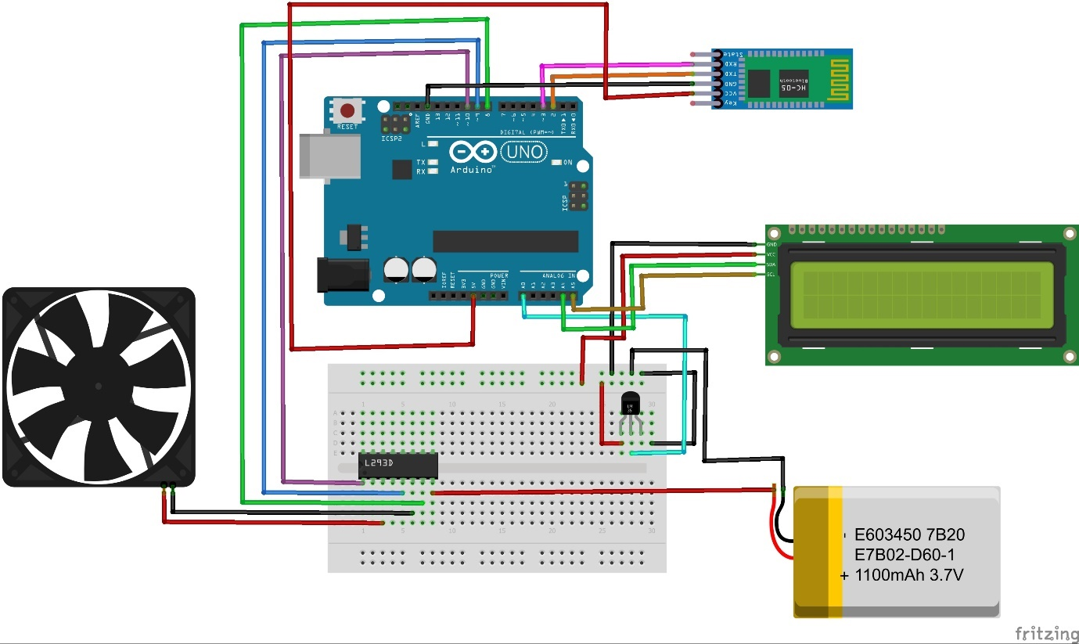
Figure 1: Printed Circuit Board (PCB)
Figure 1 Printed Circuit Board (PCB) presents the Fritzing PCB layout for our embedded system. The design utilizes an Arduino Uno as the central processing unit, interfaced with a Bluetooth module, a motor driver, and other components represented by placeholders in the schematic.
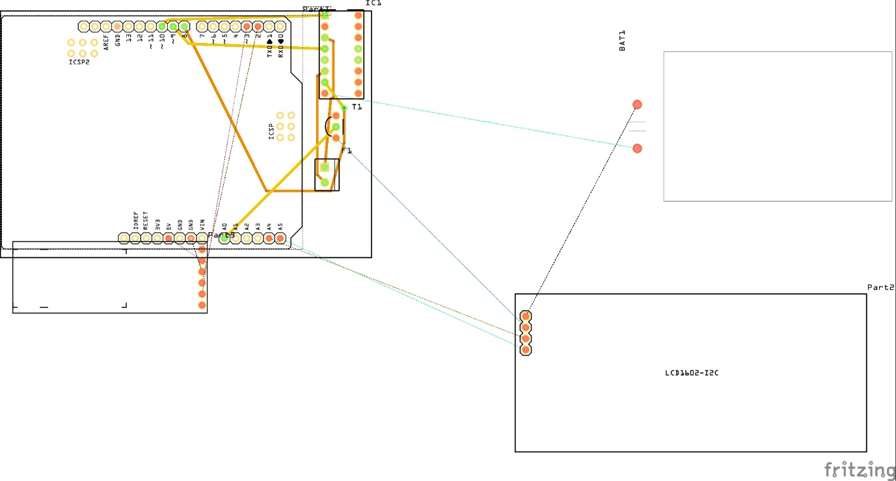
The layout details the physical arrangement of components and their interconnections on the PCB, with the green area representing the PCB itself and orange dots indicating connection points. This PCB design supportts the core functionality of our robotic arm control.

Figure 2: Breadboard Components Circuit Diagram
Figure 2: Breadboard Components Circuit Diagram, illustrates the experimental setup's circuit diagram. The system comprises an Arduino Uno microcontroller as the central processing unit, a DC motor controlled by an L293D motor driver, a temperature sensor for environmental monitoring, a Bluetooth module for wireless communication, and a 16x2 LCD display for data output. Jumper wires interconnect these components according to the depicted wiring configuration. This setup facilitates temperature-based motor control, with real-time data displayed on the LCD.
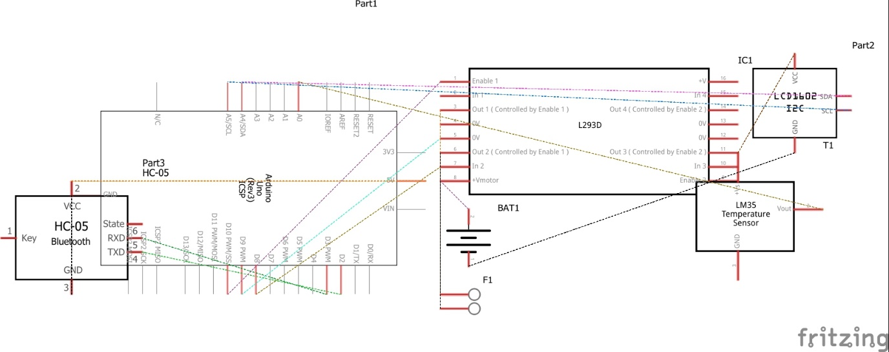
Figure: 3 Schematic Diagram
Figure: 3 Schematic Diagram presents the schematic diagram of the proposed system's hardware architecture. The core components include an Arduino Uno microcontroller, an HC-05 Bluetooth module for wireless communication, an L293D motor driver to control a DC motor (M1), and a dedicated power supply.
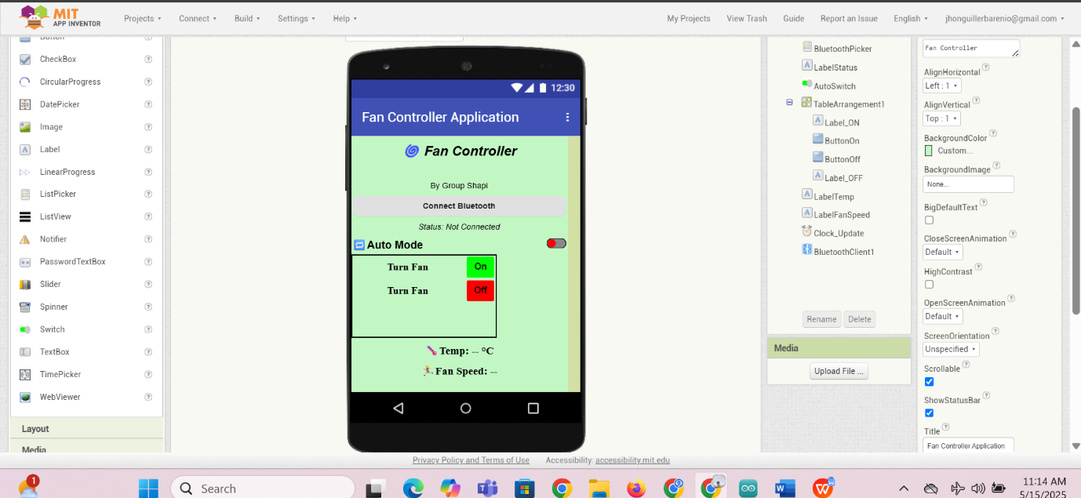
The diagram details the interconnection of these components, illustrating the data flow and control signals. This configuration enables Bluetooth-controlled motor actuation, a key functional element of the system.
Figure 4:Mit App Inventor UI

Figure:4 illustrates the user interface of the proposed system's mobile application, developed using MIT App Inventor. The application, titled Fan Controller Application, provides an interactive platform for users to control a fan system wirelessly via Bluetooth. It features a Bluetooth connection button to pair with external hardware, an “Auto Mode” toggle switch for enabling automated control, and manual control buttons labeled “Turn Fan On” and “Turn Fan Off.”
The interface also displays real-time feedback, including connection status, temperature (°C), and fan speed. This mobile interface is designed to communicate with an Arduino-based system through an HC-05 Bluetooth module, allowing seamless remote monitoring and control of the fan's operation.

CHAPTER III
System Design and Methodology
Conceptual Framework
The researchers have tackled and have decided that the study will be using the Agile Methodology where the researchers need to apply the ff: Analyse & Plan. Design, Develop, Test, Review, Finish.


- Identification of user requirements and environmental
parameters.

- A comprehensive review of existing research on Arduino-based
systems and climate control.

INPUT

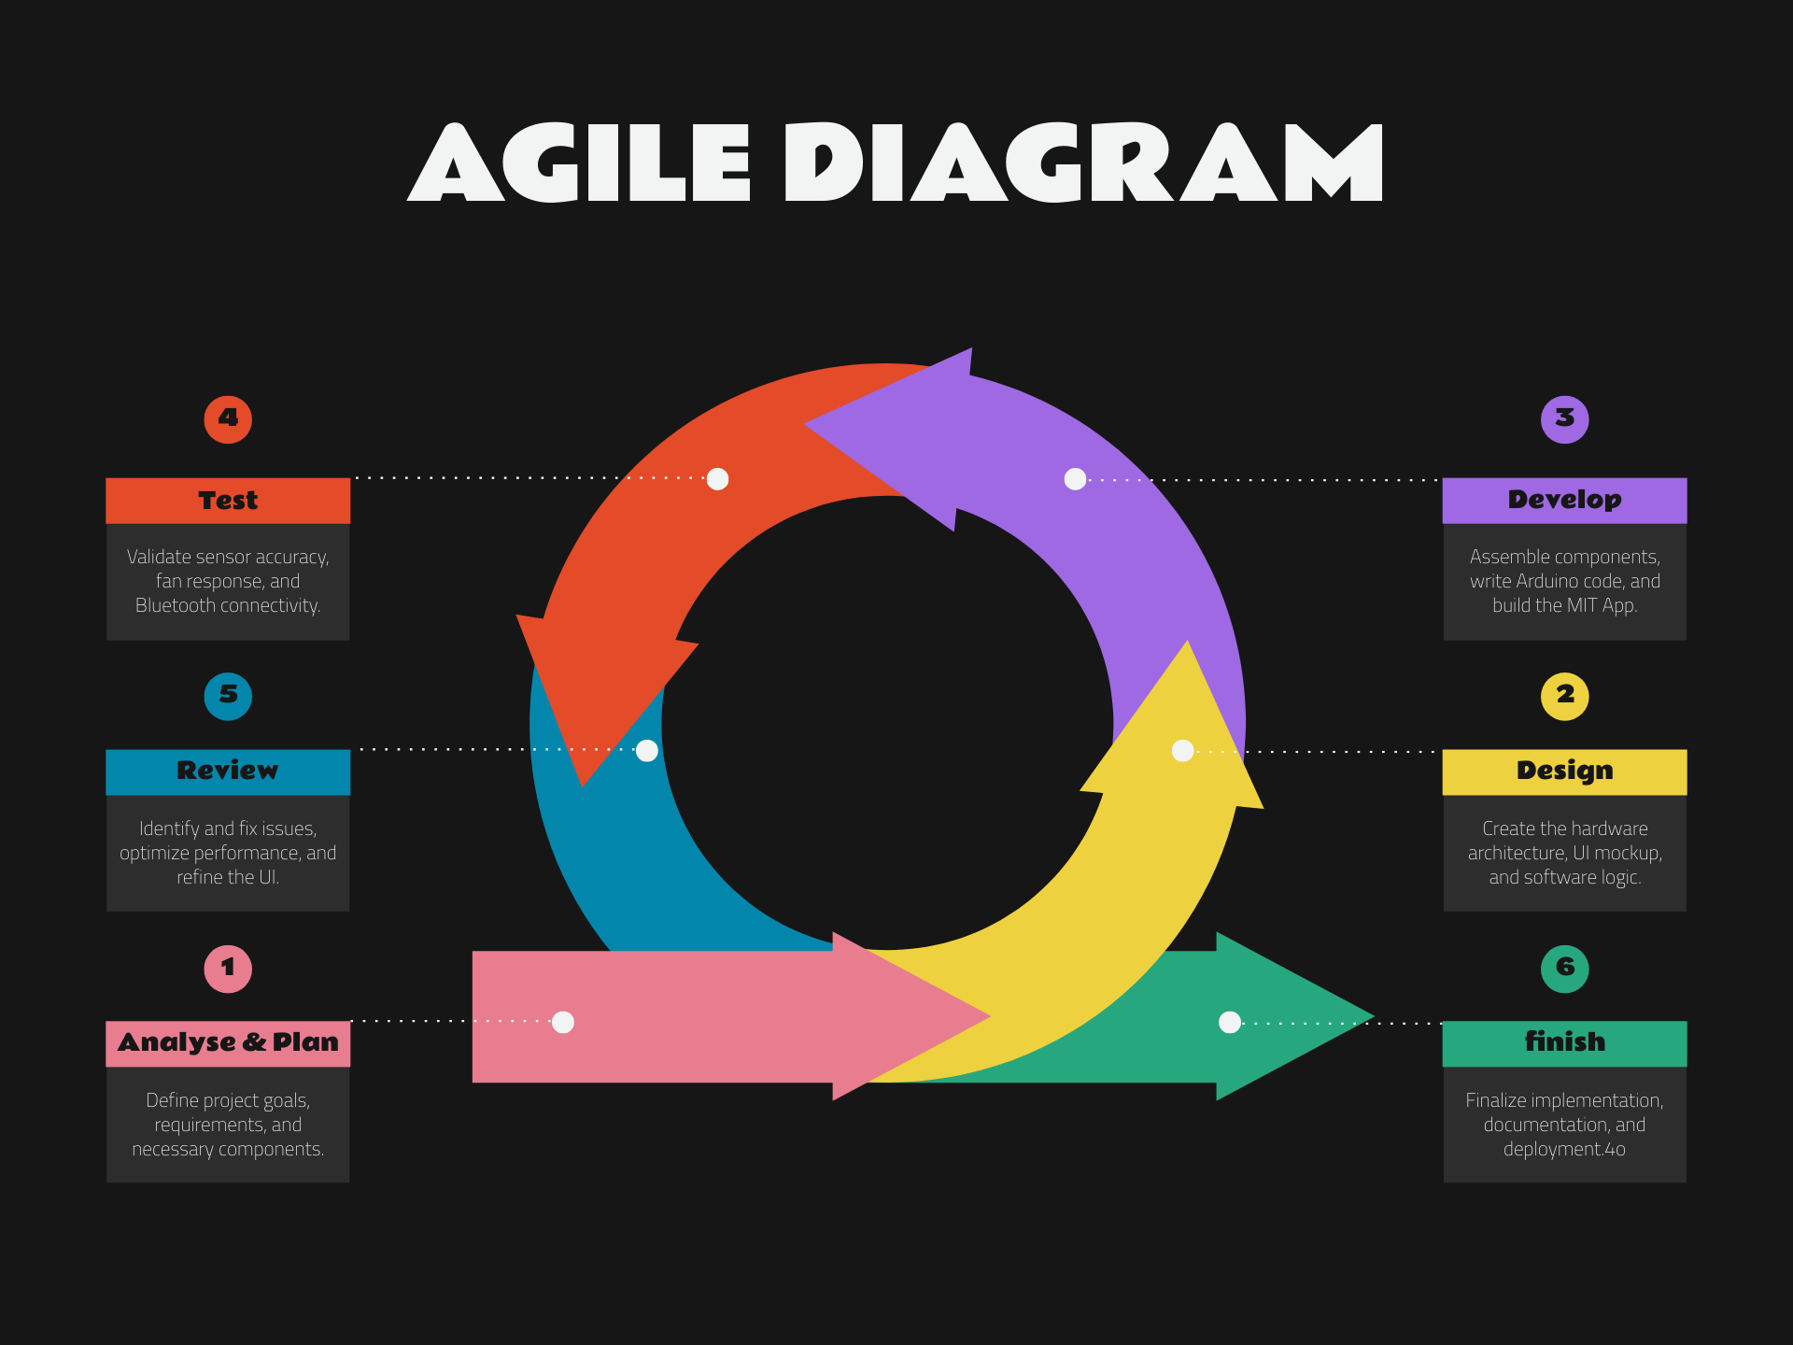
\
INPUT

PROCESS

O
U
T
P
U
T
IOT-BASED Smart Fan Temperature Controlled Using Arduino Based System

OUTPUT

IOT-BASED Smart Fan Temperature Controlled Using Arduino Based System

Figure 4. Conceptual Framework
Figure: 4 Conceptual Framework

The conceptual framework for the Smart Fan Temperature Detector using Arduino Based System, outlines the system's development process using an Agile methodology. It begins with gathering user requirements and reviewing relevant literature. The Agile process involves planning, designing, developing, testing, deploying, and reviewing the system. The final output is a functional system that securely registers students, generates unique qr codes , and authenticates individuals for various school purposes.
Firstly, in the Input Stage, the researchers began by brainstorming ideas for the project design, taking a structured approach to ensure they explored all possibilities. The researchers carefully identify and analyze any problems, making sure they fully understand the project’s scope before moving forward. The data they gathered at this stage was thoughtfully processed and organized, ensuring it was ready to be used in developing the system. To guide their work, they followed the Agile model, which focuses on breaking the project into smaller, manageable pieces. By working in cycles, they were able to gather feedback quickly and make adjustments as needed, keeping the process flexible and responsive to any changes along the way.
Secondly, in the Process Stage development of the Smart Fan Humidity Detector using Arduino Based System follows an Agile process to ensure efficiency and adaptability. The project begins with the Analyze and Plan phase, where requirements are gathered from school administrators and user stories are defined, outlining the system's core functionalities. In the Design phase, mainframes, database structures, and system architecture are created to ensure usability and scalability. During the Develop phase, the system is built incrementally across sprints, focusing on modules such as arduino model, This is followed by the Test phase, where unit, integration, and user acceptance tests are conducted to ensure functionality and reliability. In the review phase, the system is piloted with a small group, and feedback is used to refine the system evaluating sprint outcomes, gathering insights from pilot testing, and addressingAny issues.
Finally, the system is finished.Finally, the Output the newly created Smart Fan Humidity Detector using Arduino Based System is finally developed.
System Architecture / Block Diagram
This section presents the system architecture and block diagram of the proposed Temperature-controlled fan system. The architecture illustrates the interaction between hardware components such as the LM35 temperature sensor, the Temperature sensor, 16x2 I2C LCD, HC-05 Bluetooth module, L293D motor driver, 3V DC fan, and the Arduino microcontroller. It also highlights the communication flow between the Arduino and the MIT App Inventor-based mobile application.
The block diagram provides a visual representation of the system's functional structure, offering a clear overview of how data is collected, processed, and used to control the fan both automatically and manually. This foundational layout ensures efficient integration and operation of all components within the system
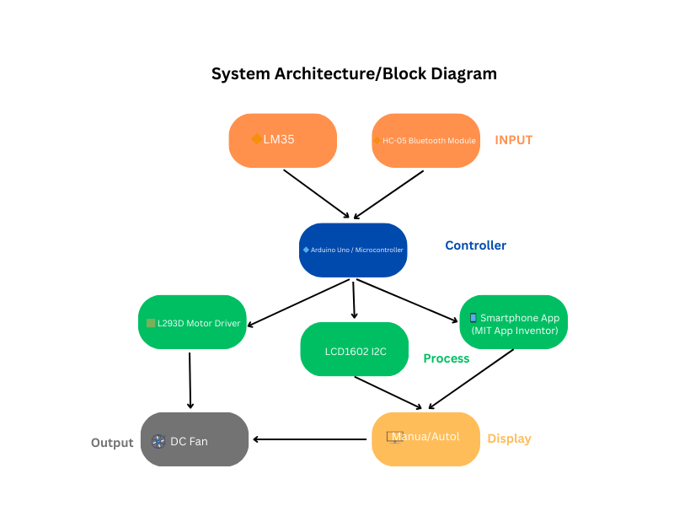Figure 5: System Archistecture/Block Diagram

Figure 5 System Architecture/Block Diagram presents a block diagram illustrating the system architecture. The system's input comprises data from a LM35 temperature sensor and control commands from a smartphone application (developed using MIT App Inventor) received via an HC-05 Bluetooth module. The controller is an Arduino Uno microcontroller, processes this input. The process involves reading the temperature from the LM35, receiving control commands, and determining the appropriate fan speed. The output is the speed of the DC fan, controlled by the L293D motor driver. The display mechanism consists of an LCD1602 I2C display, providing visual feedback of the temperature and operational status. The system allows for both automated temperature-based fan control and manual control via the smartphone application. Manual control overrides the automated temperature-based control.

Flowchart and Algorithm
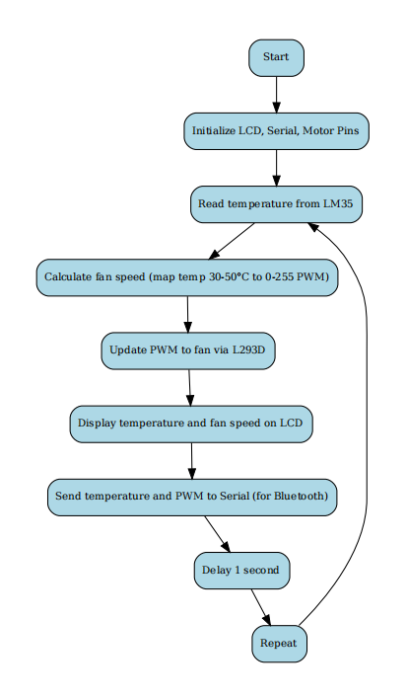

Figure 6: Flowchart and Algorithm

Figure 6. Flowchart diagram. The illustration shown above is the flow data and activities within the IOT-BASED Smart Fan Temperature Controlled Using Arduino Based System showcasing the process of our project, procedure, and the flows of the data diagram while installing the project.
Prototyping Methodology
The IoT-Based Smart Fan Temperature Control System Using Arduino The development of this system will employ an iterative prototyping methodology that centers on user feedback. The process will commence with a conceptualization phase, where initial design ideas are generated and system functionality is outlined via a high-level block diagram.
A low-fidelity prototype, constructed from readily available materials, will then be created to simulate the user interface and system behavior. This prototype will undergo user testing to gather feedback on usability and functionality, directly informing the subsequent development stages. Based on this feedback, a high-fidelity prototype will be developed using the actual hardware components.
The Arduino, sensors, actuators, closely replicating the final product. This high-fidelity prototype will be rigorously tested for functionality, reliability, and user experience. The test results will then drive further design iterations, allowing for the resolution of any identified issues and refinement of system performance and usability.
This iterative cycle of testing, refinement, and retesting will continue until the prototype completely satisfies the specified requirements and user expectations. Only upon achieving this will the design be finalized, and comprehensive documentation prepared for production.

Software Development Life Cycle (SDLC)

Figure 7 Software Development Life Cycle
The Agile diagram demonstrates a flexible and repeatable development process that supports ongoing improvement. It includes six key phases: Analyze & Plan, Design, Develop, Test, Review, and Finish. This method is especially beneficial for systems like the IoT-Based Smart Fan Temperature-Controlled Using Arduino, where both hardware and software must work together efficiently.
The process begins by outlining goals and identifying essential components such as sensors, microcontrollers, and Bluetooth modules. This stage ensures the project has a clear direction. During the design phase, the system’s structure is organized, including how sensor data will trigger the fan and how commands will be handled through a mobile app.
Development involves assembling the components and writing the necessary code. The Arduino is programmed to control the fan based on temperature readings, and a mobile app is created to let users interact with the system. Agile promotes building in small steps, reducing errors and improving workflow.mIn the testing phase, each component is checked for accuracy and functionality. This ensures that sensor readings, fan response, and Bluetooth connectivity all perform reliably. The review phase then focuses on refining the system based on performance and feedback.
The project concludes with final adjustments and documentation, but Agile allows for future improvements by revisiting earlier stages. This makes the approach ideal for developing smart systems that combine real-time sensor data with user interaction through software.

Tools and Technologies Used

Programming Tools and Languages
The researchers have used the following to ensure efficient control, monitoring, and functionality of the IOT-BASED Smart Fan Temperature Controlled Using Arduino Based System
Componnents | Minimum Requirements | Description
C++ | The minimum system requirements for C++ include a processor, 2GB RAM (4GB recommended), and 5GB free disk space. It runs on Windows 7/8/10/11, macOS 10.12+, or Linux with a C++ compiler like GCC, MSVC, or Clang. An IDE such as CodeBlocks, Dev-C++, or Visual Studio is optional but enhances development. | C++ is a fast, efficient programming language supporting procedural and object-oriented programming, widely used for system software, game development,and high-performance applications.
MIT App Inventor | The minimum requirements for MIT App Inventor include a computer with at least 2GB RAM, a modern web browser like Chrome or Firefox, and an active internet connection. For app testing, an Android device running Android 5.0 or higher is recommended, or users can use the built-in emulator. | MIT App Inventor is a visual programming platform for creating Android apps using a drag-and-drop interface and block-based coding. It is user-friendly, ideal for beginners, and supports integration with sensors, Bluetooth, and cloud services for interactive applications.
Arduino Ide | The minimum requirements for Arduino IDE include a computer with at least 2GB RAM, a modern processor, and 100MB of free disk space. It runs on Windows 7, 8, 10, 11, macOS 10.10 or later, and Linux. A USB port or Bluetooth is needed for uploading code to Arduino boards. | Arduino IDE is an open-source platform used to write, compile, and upload code to Arduino boards. It supports C++ programming, runs on multiple operating systems, and provides a simple interface for embedded system development.
Fritzing | The minimum requirements for Fritzing include a computer with at least 2GB RAM, a 1GHz processor, and 500MB of free disk space. It runs on Windows 7 or later, macOS 10.10 or later, and Linux with OpenGL 2.0 support for graphics rendering. | Fritzing is an open-source software for designing, prototyping, and documenting electronic circuits. It provides a user-friendly interface for creating circuit diagrams, PCB layouts, and breadboard simulations, making it ideal for hobbyists, educators, and engineers.
Tinkercard | Tinkercad is a web-based application that requires a computer with at least 2GB RAM, a modern web browser like Chrome, Firefox, or Edge, and a stable internet connection. It runs on Windows, macOS, Linux, and Chrome  OS without the need for installation. | Tinkercad is a web-based design tool for 3D modeling, electronics simulation, and coding. It is user-friendly and widely used for educational purposes, allowing beginners to create circuits, program  microcontrollers, and design 3D objects without installing software.

Table 2 Programming Tools and Languages
The table 2. Above shows that The researchers have used various programming tools and languages, as shown in the table above, to ensure the efficient control, monitoring, and functionality of the IOT-BASED Smart Fan Temperature Controlled Using Arduino Based System. These tools were carefully chosen based on key factors such as compatibility with hardware components, ease of development, real-time data processing, scalability, and user-friendly interface design. By integrating these technologies, the system ensures seamless communication between sensors, the fan, and the user, enabling automated temperature regulation and improved energy efficiency. Additionally, the selected tools allow for real-time monitoring, remote control, and data visualization, enhancing both system reliability and user experiee.

Cost and Benefits Analysis
 | Cost and Benefit Analysis |  |  | Total Cost
C  C  O  S  T | Development | - Arduino Uno Kit  Bluetooth | 1,463  246
C  C  O  S  T | Development | Total |  | 1,709
C  C  O  S  T | Operational | -2pcs 3.7 Lithium Battery  -Miniature Room  -Cellphone Battery  -Cellphone | 112  580  360  3000
 |  | Total |  | 4,052
 |  |  | Total | 5,761
Table 3 Cost and Benefit Analysis
Table 3 presents the Cost and Benefit Analysis of the proposed system, divided into development and operational expenses. The development cost includes an Arduino Uno kit priced at 1,463 and a Bluetooth module costing 246, totaling 1,709. Operational costs cover components necessary for testing and demonstration, such as two 3.7V lithium batteries (112), a miniature room setup (580), a cellphone battery (360), and a cellphone (3,000), amounting to 4,052. The overall total cost of the project is 5,761, encompassing both hardware development and operational implementation.
Chapter IV
Implementation, Results and Discussion

System Implementation
The project is a temperature-controlled fan system that automatically adjusts fan speed based on ambient temperature and displays real-time data on an I2C LCD. Additionally, Bluetooth (HC-05) is integrated for manual control and monitoring via mobile app developed using MIT App Inventor.

Key Technical Features:
Temperature Measurement: The system continuously monitors room emperature using an LM35 sensor, which provides real-time data for temperature-based fan control.
Fan Control: The 3V DC fan is controlled through the L293D motor driver, adjusting its speed based on temperature readings. When the temperature exceeds a set threshold, the fan speed increases; when the temperature is low, the fan slows down or turns off.
Automation and Energy Efficiency: The system optimizes energy use by adjusting fan speed based on real-time conditions, preventing unnecessary power consumption.
User Interaction: The system can display real-time temperature readings on a 16x2 I2C LCD and allow users to manually adjust settings via a mobile application.
Bluetooth Connectivity: The HC-05 Bluetooth module enables wireless communication between the Arduino and the mobile application for remote fan control and temperature monitoring.

Technologies Used:
Arduino Microcontroller: The Arduino Uno serves as the system’s central processing unit, processing data from the LM35 sensor and controlling the fan speed through the L293D motor driver.
Advantages: Easy to program, cost-effective, and widely supported for sensor and motor integration.
LM35 Temperature Sensor: The LM35 accurately measures temperature and provides real-time data for fan control.
Advantages: High accuracy, simple integration with Arduino, and a temperature range of -55°C to 150°C.
L293D Motor Driver: This module allows the Arduino to control the 3V DC fan’s speed efficiently.
Advantages: Provides bidirectional control, isolates the Arduino from high-power components, and ensures stable fan operation.
3V DC Fan: The primary output device that regulates airflow based on temperature readings.
Advantages: Energy-efficient, easily controlled through the motor driver, and suitable for small-scale cooling applications.
16x2 I2C LCD: Displays real-time temperature readings and system status.
Advantages: Reduces wiring complexity and provides a clear display for monitoring.
HC-05 Bluetooth Module: Enables wireless communication between the system and a mobile application for remote fan control.
Advantages: Reliable connectivity, easy integration with Arduino, and support for serial communication.
Power Supply & 2 Pcs 3.7V Lithium Battery: Supplies power to the Arduino and other components, ensuring stable system operation.
Advantages: Provides regulated voltage for circuit stability and prevents fluctuations.

System Operation:
- System Initialization: Upon startup, the Arduino initializes the LM35 sensor, fan, LCD, and Bluetooth module.
- Temperature Data Collection: The LM35 continuously monitors the temperature and sends data to the Arduino.
- Threshold Comparison: The Arduino compares the temperature with predefined values:
  - If temperature > set threshold, the fan runs at high speed.
  - If temperature is within the threshold range, the fan operates at medium speed.
  - If temperature < set threshold, the fan slows down or turns off.
- Fan Operation: The L293D motor driver adjusts the fan’s speed based on the Arduino’s signal.
- Bluetooth Connectivity: The user can monitor temperature and control fan speed through a mobile application connected via the HC-05 Bluetooth module.
- Energy Efficiency: The system ensures the fan operates only when needed, reducing unnecessary power consumption.
This smart system provides an efficient, automated solution for temperature regulation, making it ideal for indoor environmental control.
Testing and Results
Testing Procedure:
1. Power on the system and observe LCD for welcome message.
2. Vary ambient temperature using a heat source.
3. Observe fan behavior as temperature changes.
4. Connect via Bluetooth using the MIT App: - Switch between Auto and Manual modes. - In Manual mode, test fan speed control using sliders.

Results Summary
Test Condition | Temp(°C) | Mode | Fan Speed(PWM) | App Sync
Ambient Room | 31°C | Auto | 0 | Yes
Warm Hand on Sensor | 37°C | Auto | 100 | Yes
Manual Mode | - | Manual | Set to 150 | Yes
Frequent Change in Temperature | - | Auto | Flexible | Yes
Table 4 Testing and Results
Challenges Encountered
1. Voltage Compatibility (HC-05 RX pin): Arduino TX sends 5V signals; HC-05 is 3.3V-tolerant. Used a resistor voltage divider.
2. Fan Power Drain: Fan caused voltage drop; isolated power using a 3-6V battery for fan only.
3. Noise in LM35 Readings: Added averaging for stable temperature results.
4. Serial-Bluetooth Conflict: Serial Monitor and HC-05 both use Serial. Only one can be used at a time unless using Software Serial.
5.There is fluctuations regarding reading the temperature and is affecting fan control
6. Voltage requirements are not aligned and causing the l293d to spark out. Replaced the power supply that can hold stable voltage for the l293d, fan and lcd.
7. Using 9v battery and causing the fan to burn. Use required voltage lithium batteries.

System Evaluation
Parameter | Evaluatiokn
Temperature Accurancy | ±0.5 C (after averaging)
Fan Response | Smooth Pwm Transition
LCD Display | Clear, Updated every second
Bluetooth App | Responsive
Power Handling | Stable after separating power
Table 5 System Evaluation
Summary of Findings
The project successfully implemented a closed-loop fan control system using an LM35 temperature sensor and an L293D motor driver. Real-time temperature readings and fan speed were displayed on an LCD screen, offering immediate feedback. Integration with a Bluetooth module allowed remote control, and the accompanying mobile app provided an easy-to-use interface for both monitoring and manual adjustments. This system design shows potential for applications in smart home environments or IoT-based cooling solutions.

APPENDICES

A.Project Team Assignments Form (A)

Team Alias | Shapi

Name and Signature | Project Role | Email address | Mobile Number
Enaga, Anngelica | Project Manager | Angelicaenaga6@gmail.com | 0926241850
Bocado, Precy Faith | System Analyst | Preseefategarcia123@gmail.com | 09291573842
Barenio, Jhon Guiller | Programmer | Jhonguillerbarenio@gmail.com | 09984411692
Ruiz, Nemfa | Documenter
Paciente, Lyka | Tester |  | 09979860623

Noted: Approved:

JETTY A. CASIDO, MSIT ZENAIDA D. CALUMPANG, MSIT, Ed. D.
Subject Adviser Dean, CAS

B.PreProposal Statement Template (B)

Project Title:
Proponents/ Researchers:
Scope of the Study
Limitations of the Study:
Objectives of the study

Noted: Approved:

JETTY A. CASIDO, MSIT ZENAIDA D. CALUMPANG, MSIT, Ed. D.
Subject Adviser Dean, CAS

C.Project Working Title Form (C)
Proponents/Researchers:
- Anngelica Eñaga
- Precy Faith Bocado
- Jhon Guiller E. Barenio
- Ruiz Nemfa
- Lyka Paciente

Proposed Project Title:
IOT-BASED Smart Fan Temperature Controlled Using Arduino Based System

Submitted by:  Anngelica Eñaga  (Signature of Project Manager over printed name)  Date: ___________________ | Noted:  Jan Rey Estrosas  (Signature of Adviser over printed name)  Date: ___________________
Recommending Approval:  Jetty Casido  (Signature of Subject Adviser over printed name)  Date: ___________________ | Recommending Approval:  Zenaida D. Calumpang  (Signature of Dean over printed name)  Date: ___________________
***Accomplish in 3 copies/


D.Invitation for Panel Members to the Capstone Project Proposal Hearing (D)





- Grammarian's Certificate (F)
May 17, 2025

G R A M M A R I A N’ S C E R T I F I C A T E
This is to certify that the undersigned has reviewed and went through all the pages of the proposed project study / research entitled “IOT-BASED Smart Fan Temperature Controlled Using Arduino Based System” as against the set of structural rules that govern the composition of sentences, phrases, and words in the English language.

Signed:

______________________
Grammarian

Conforme:

______________________
Project Manager

G. Source Code – Arduino sketch files
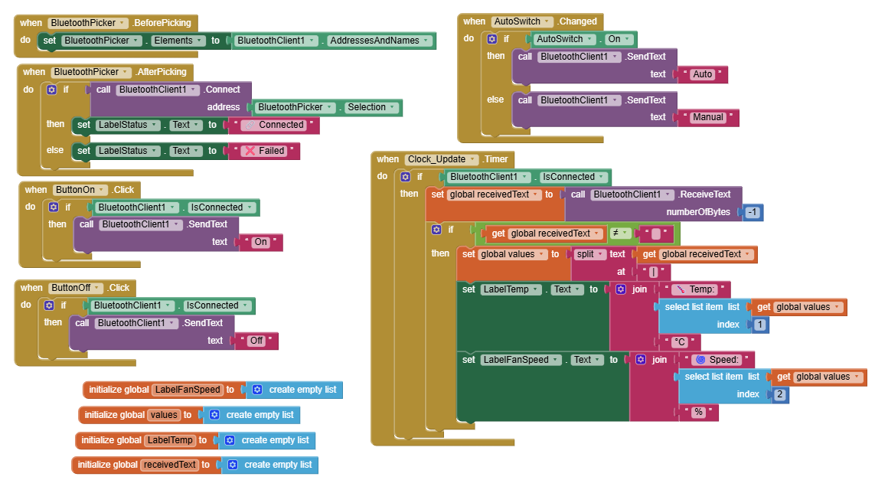
Figure 9: Mit Application Code Blocks

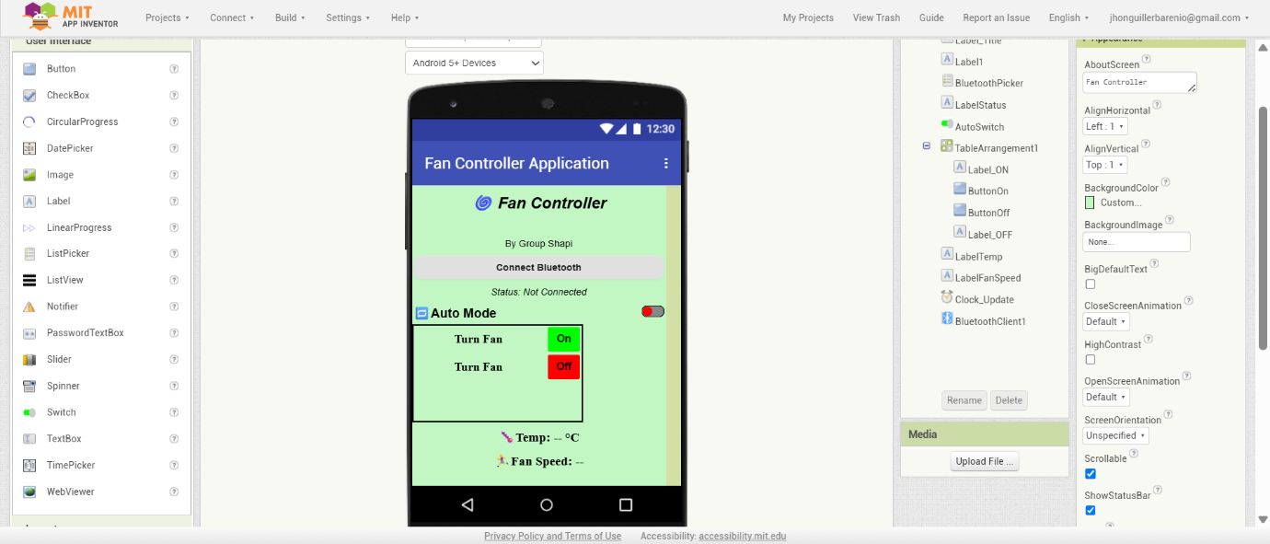
Figure 10: Mit App Inventor UI

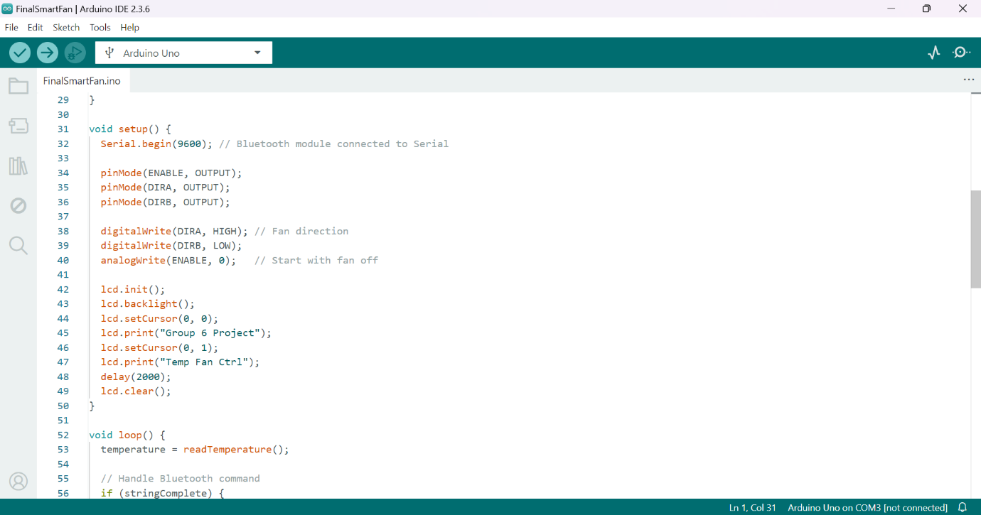
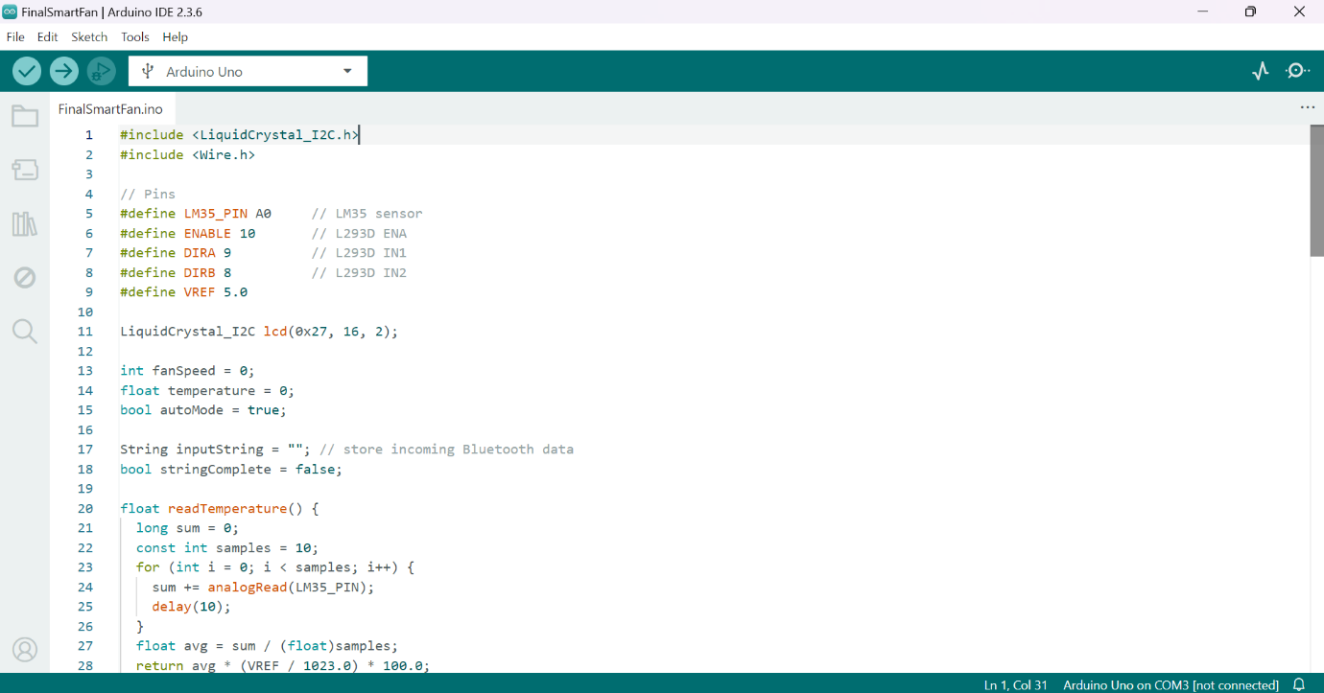
G. Source Code – Arduino sketch files
Figure 11: Arduino Code
Figure 12: Arduino Code Continuation
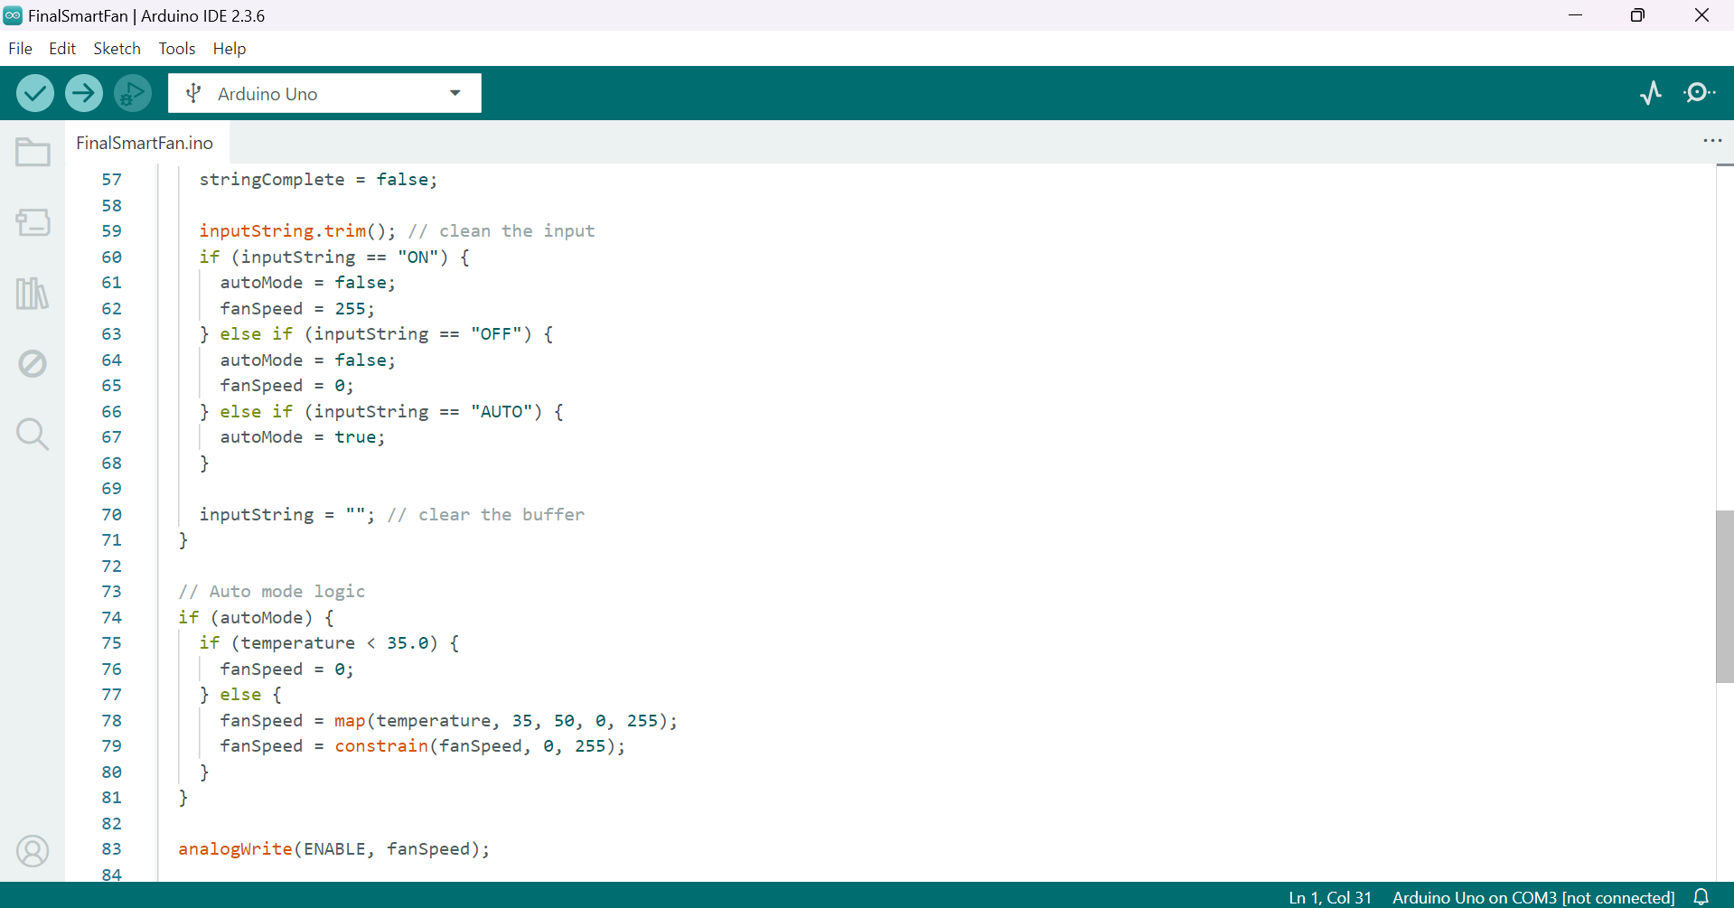
Figure 13: Arduino Code Continuation 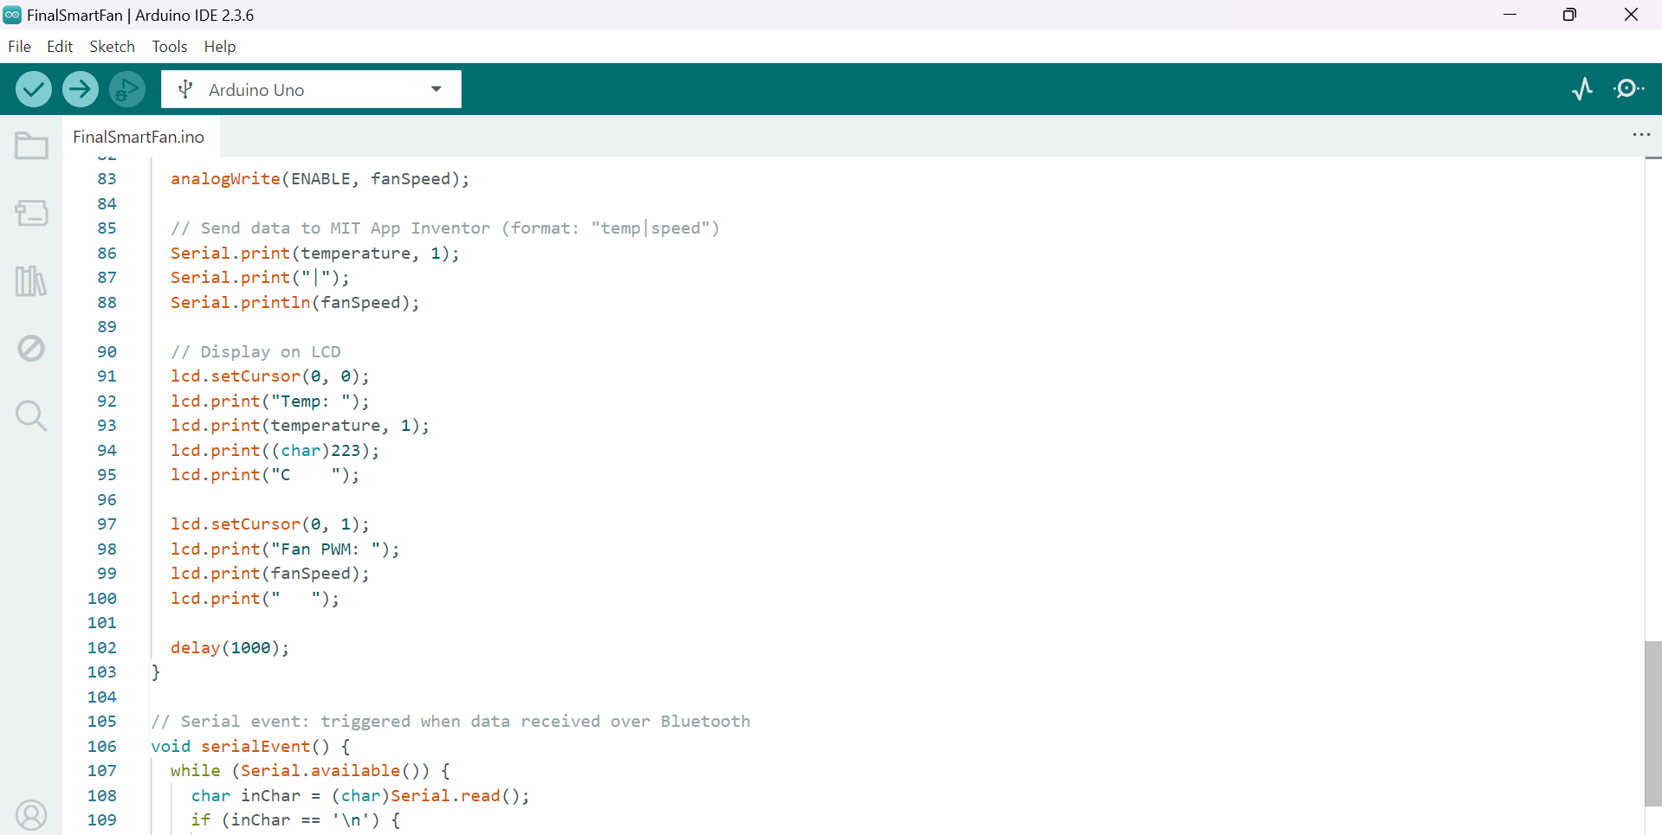
Figure 14: Arduino Code Continuation
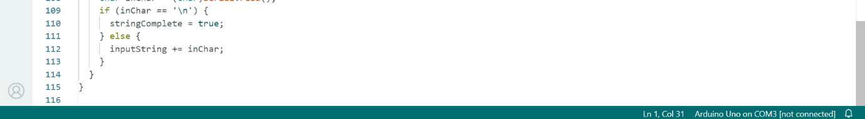
Figure 15: Arduino Code Continuation

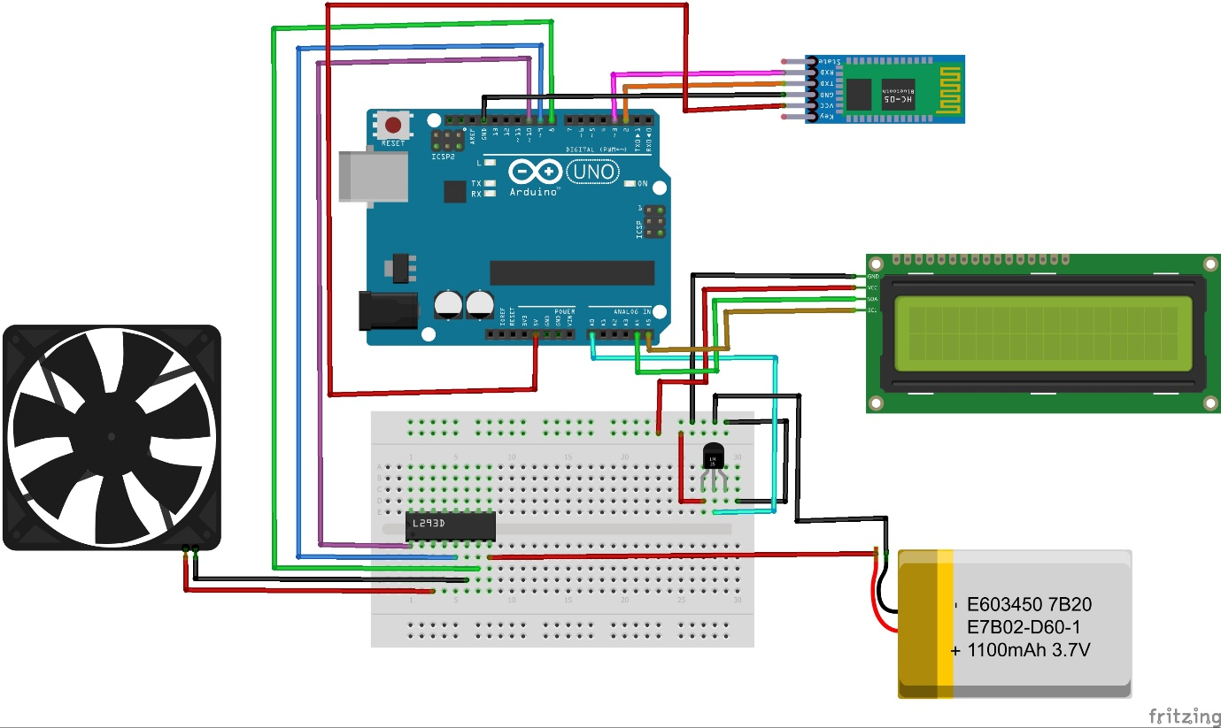
H.Circuit Diagrams – Wiring diagrams, Fritzing output

Figure 16: Circuit Diagram
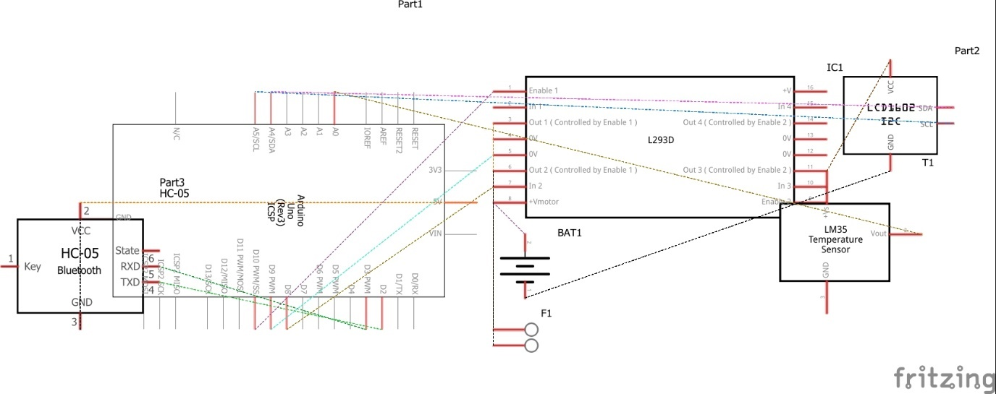

Figure 17: Schematic Diagram

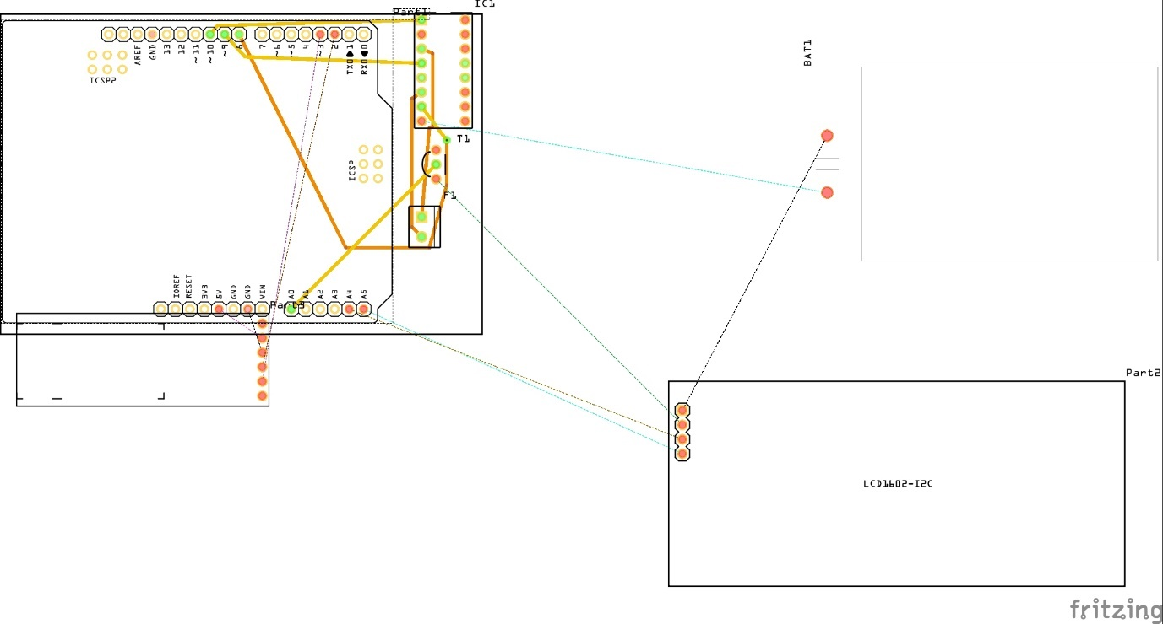
Figure18: PCB Diagram

J.Sample Output – Screenshots of LCD output, serial monitor logs, photos of prototype

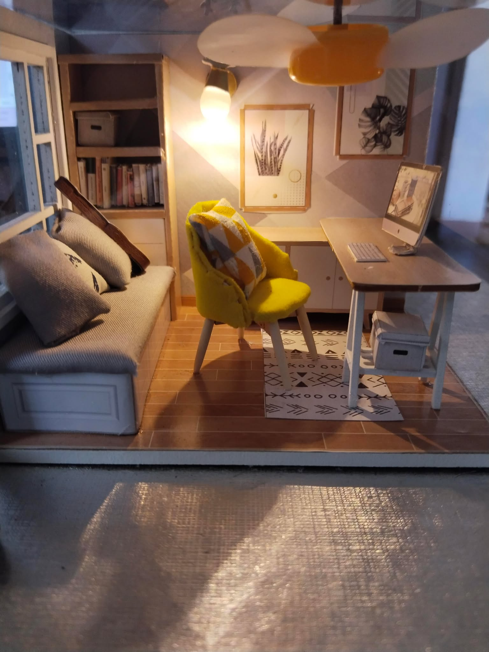

Figure 19: Sample Output
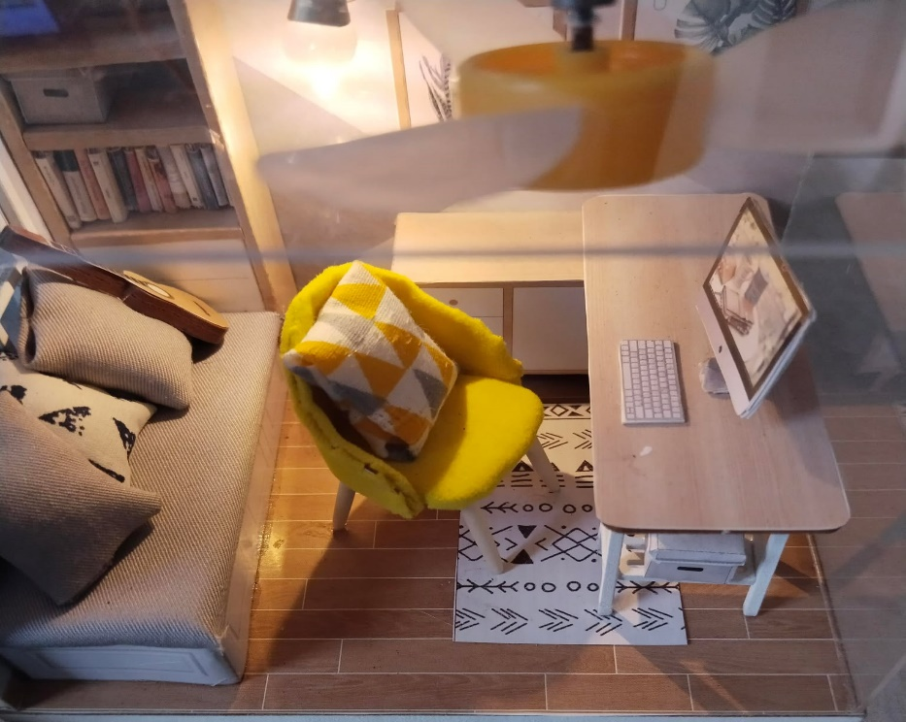

Figure 20: Sample Output

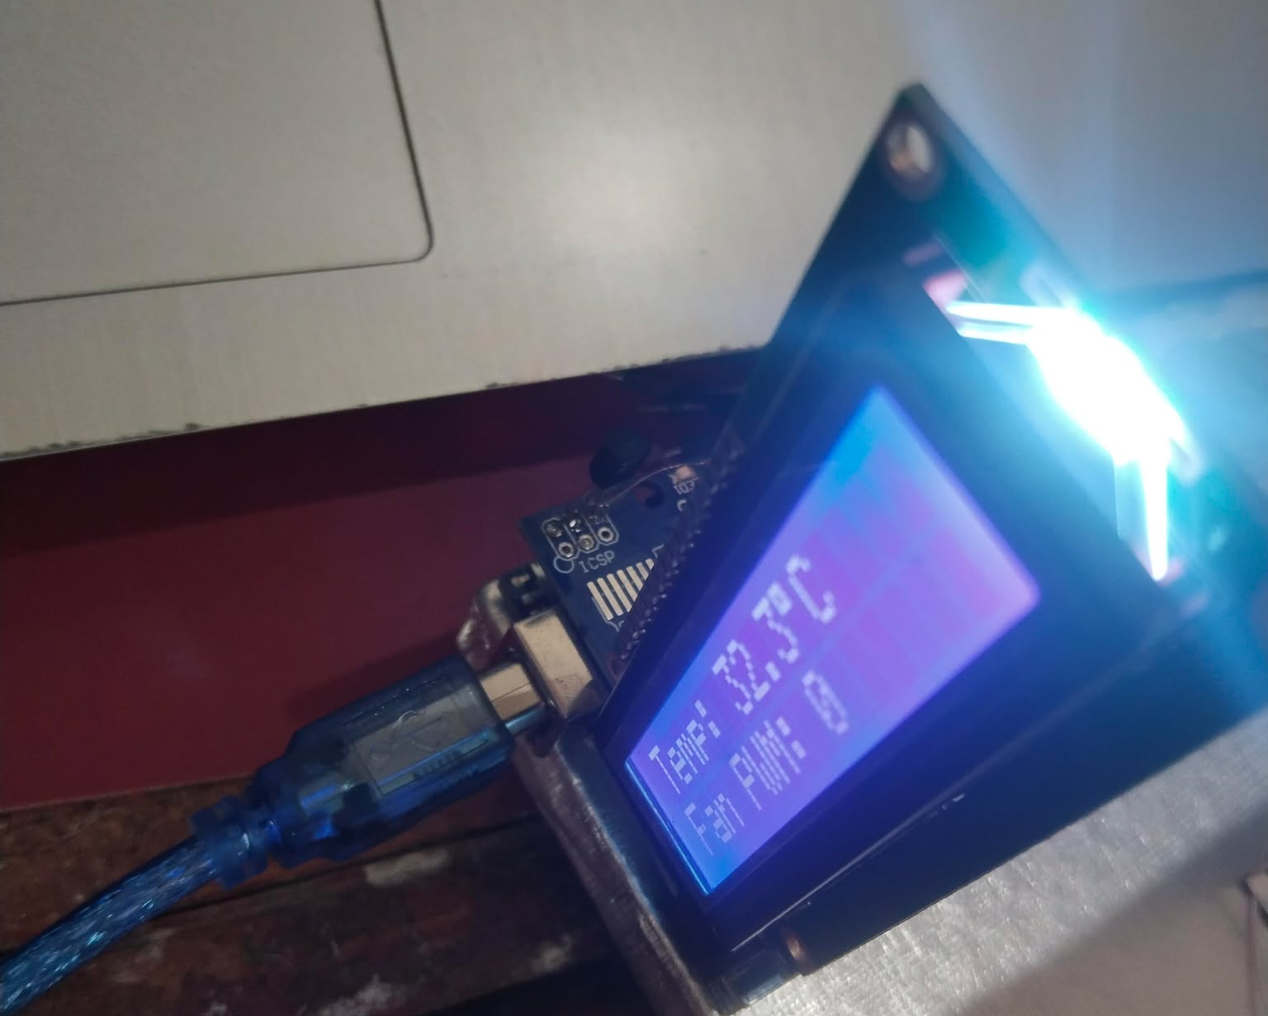

Figure 21: Sample Output
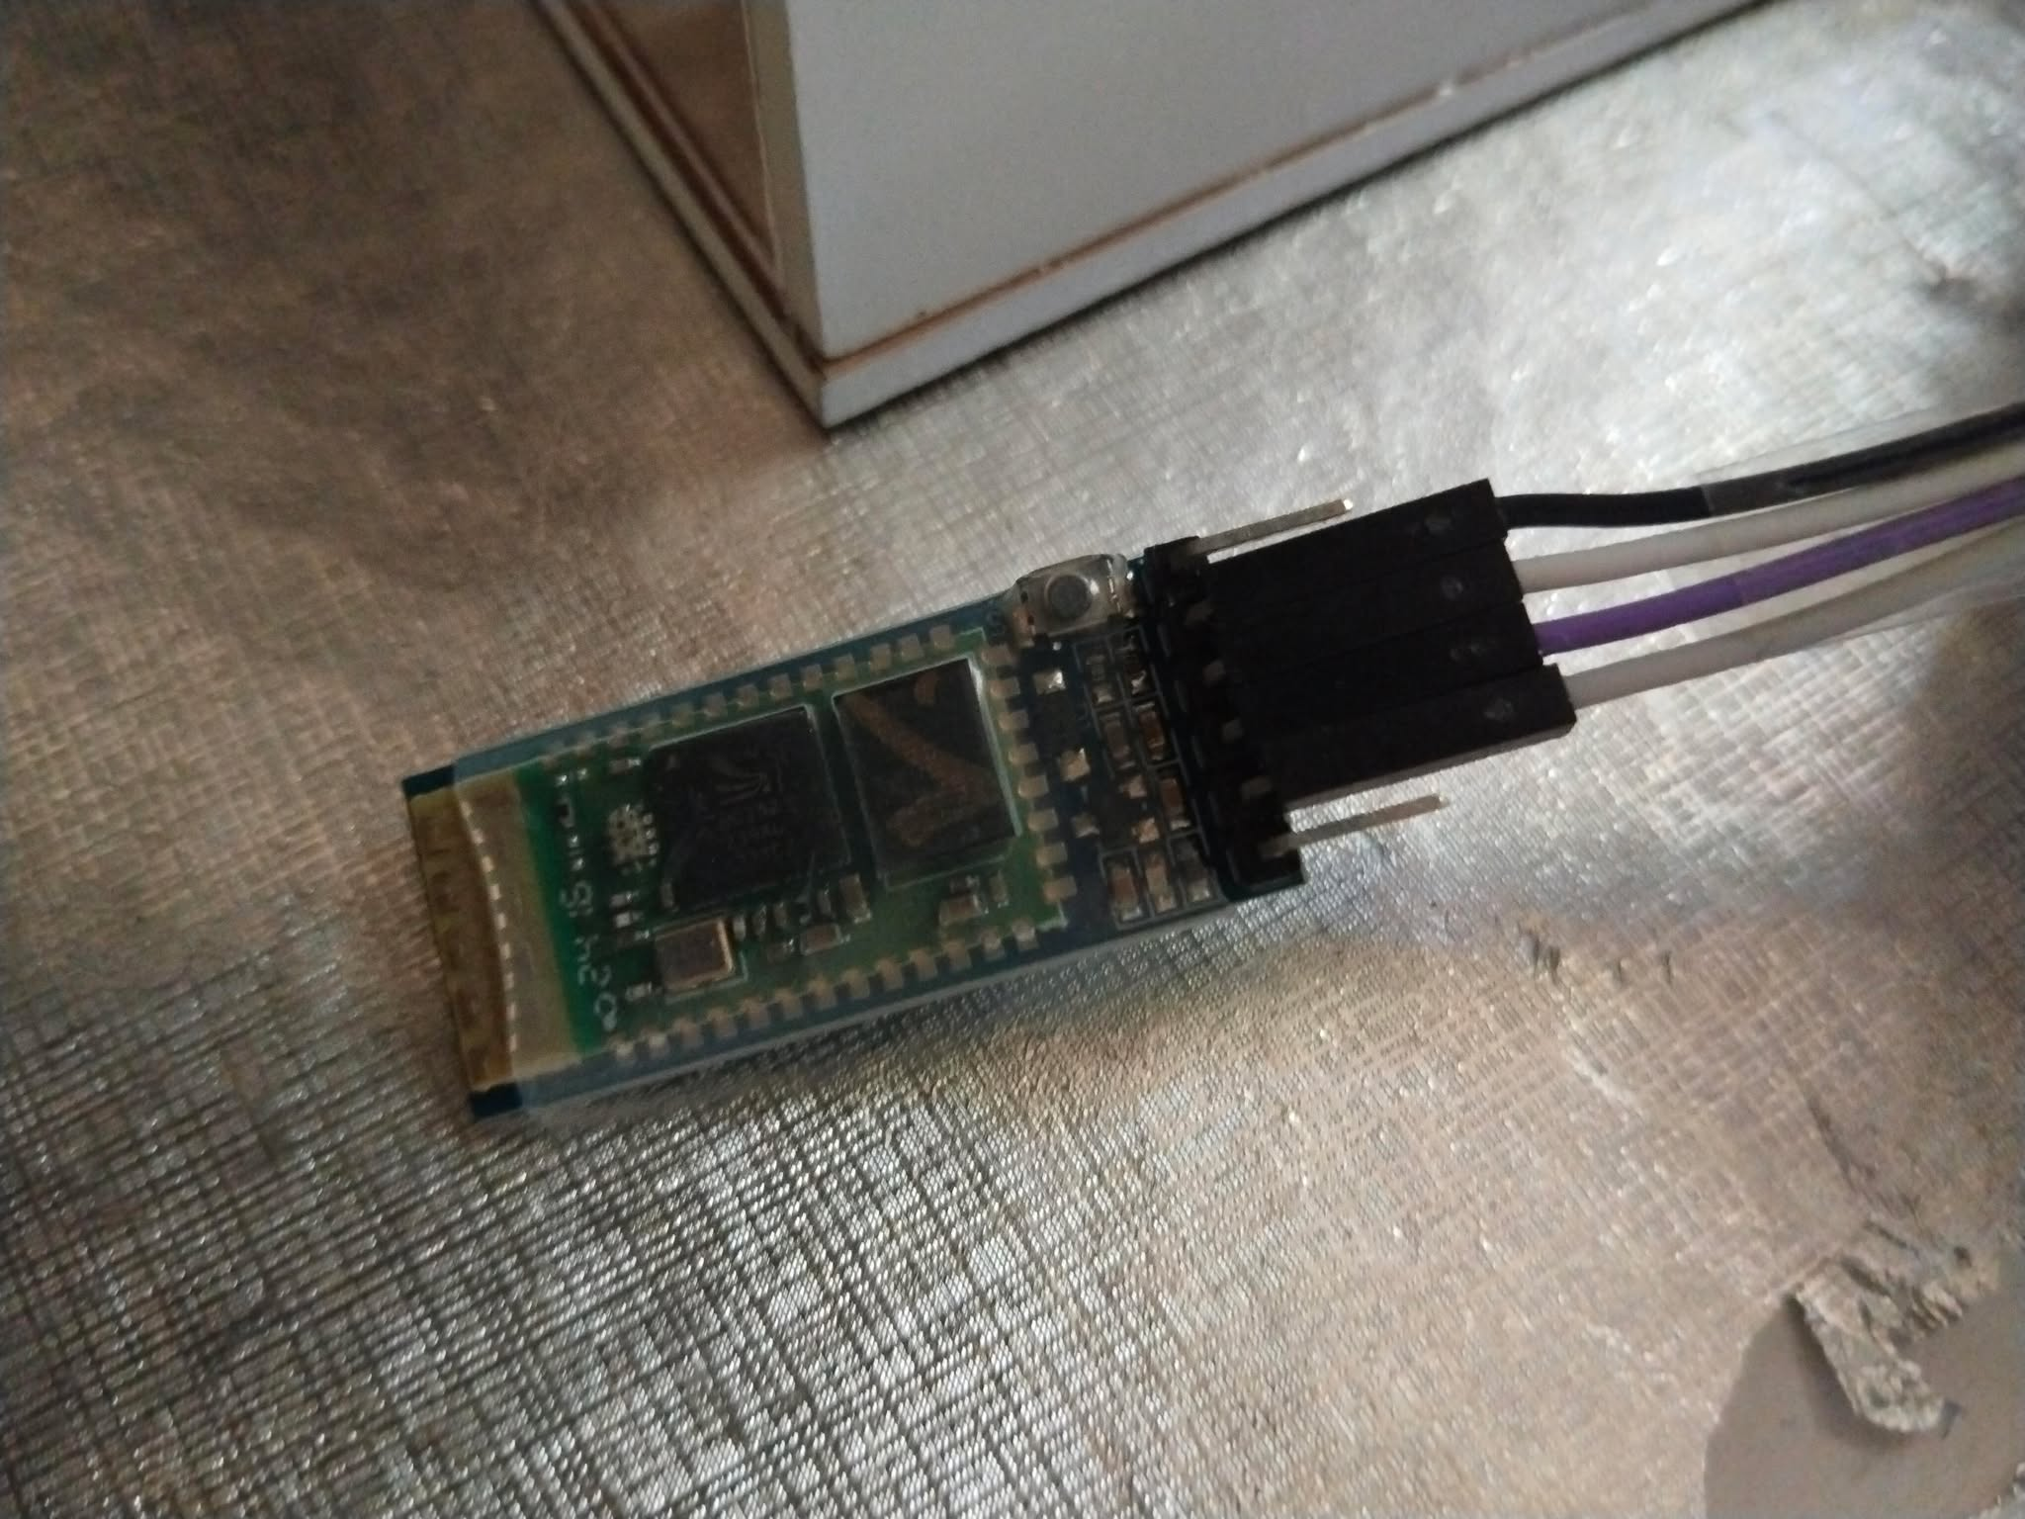

Figure 22: Sample Output

K. Researchers Profile






References
References
Akin-Ponnle, A. E. (2024). An eco-friendly and low cost IoT-based room temperature control by fan speed regulation for tropical use. Davao University.
Balais, M. H. B., Vallecera, M. V. B., & Perin, M. A. D. (2022). Temperature-controlled home automation using Arduino. Bohol Island State University – Main Campus, Tagbilaran City, Bohol, Philippines.
https://www.researchgate.net/publication/362231217_TEMPERATURECONTROLLED_HO ME_AUTOMATION_USING_ARDUINO
Buco, R. A., Cueva, A., Deniega, J., & Perodez, K. A. (2025). Smart room temperature regulation with responsive Arduino-driven temperature-controlled fan system. Association of Science and Mathematics Coaches of the Philippines.
https://hmjournals.com/journal/index.php/IJRISE/article/view/5316
Casinillo, R. M. L., Arceta So, A. L., Mandaya, M. V., & Dabalos, S. A. J. (2024).
Development of Arduino-based high heat detector temperature control prototype for
household appliances. Liceo de Cagayan University.
https://ijra.iaescore.com/index.php/IJRA/article/view/20620

Foysal, M. R., Hossain, R. A., Islam, M. M., Sharmin, S., & Moon, N. N. (2021). IoT-based temperature control system of home by using an Android device. Daffodil International
University.
https://www.researchgate.net/publication/354079580_IoT_Based_Temperature_Control_Syste m_of_Home_by_using_an_Android_Device.
Ghadage, S., Dhekale, P., Randive, A., & Narsale, D. (2021). IoT-based energy-efficient smart
ceiling fan for home automation. University Of Mumbai .
Hendajani, F., Mughni, A., Wardhani, I. P., & Hakim, A. (2022). Modeling automatic room temperature and humidity monitoring system with fan control on the Internet of Things.
STMIK Jakarta STI&K.;
https://journal.binus.ac.id/index.php/comtech/article/view/7433
Kanchanasatian, K. (2022). Automatic speed control and turning ON/OFF for smart fan by temperature and ultrasonic sensor. Rajamangala University of Technology Thanyaburi.
https://iopscience.iop.org/article/10.1088/1757-899X/325/1/012022
Kumar, A., & Sharma, V. (2021). Arduino microcontrollers in environmental monitoring: Affordability and reliability.
Requites, J. C. M., Paroccho, M. A., Vinegas, N., & Oqiuno, V. H. (2023). IoT-based temperature monitoring and automatic fan control using ESP32.
Sinha, G. R., & Raju, S. K. (2020). Automatic temperature control system using Arduino.

Tanmai, B. L., & Rishitha, K. (2020). Temperature-controlled fan using Arduino.
Abyys, K. (2023). Fan speed control with temperature sensors.

